1. Create a Flask application with an /api route. When this route is accessed, it should return a JSON list. The data should be stored in a backend file, read from it, and sent as a response.

from flask import Flask, jsonify
import json

app = Flask(__name__)

@app.route('/api')
def get_data():

with open('data.json', 'r') as file:
data = json.load(file)

return jsonify(data)

if __name__ == '__main__':
app.run(debug=True)

The data is stored in a file called data.json
When /api route is accessed:
- The file is opened
- Data is read using json.load()
- Data is converted into JSON response using jsonify()
The response is displayed in the browser

Python3 app.py

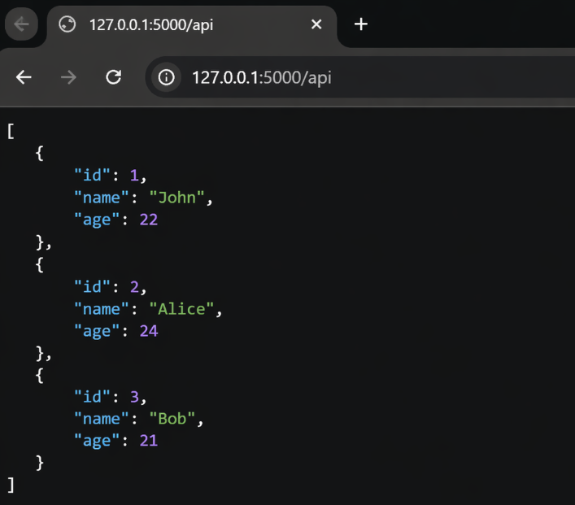

2. Create a form on the frontend that, when submitted, inserts data into MongoDB Atlas. Upon successful submission, the user should be redirected to another page displaying the message "Data submitted successfully". If there's an error during submission, display the error on the same page without redirection.

Backend

from flask import Flask, render_template, request, redirect, url_for
from pymongo import MongoClient

app = Flask(__name__)

client = MongoClient("your_mongodb_connection_string")
db = client["testdb"]
collection = db["users"]

@app.route('/', methods=['GET', 'POST'])
def form():
if request.method == 'POST':
try:
name = request.form.get('name')
email = request.form.get('email')

collection.insert_one({
"name": name,
"email": email
})

return redirect('/success')

except Exception as e:
return render_template('form.html', error=str(e))

return render_template('form.html')

@app.route('/success')
def success():
return "Data submitted successfully"

if __name__ == '__main__':
app.run(debug=True)

Frontend

<!DOCTYPE html>
<html>
<head>
<title>Form</title>
</head>
<body>

<h2>Enter Details</h2>

<form method="POST">
Name: <input type="text" name="name" required><br><br>
Email: <input type="email" name="email" required><br><br>
<button type="submit">Submit</button>
</form>

{% if error %}
<p style="color:red;">{{ error }}</p>
{% endif %}

</body>
</html>

- User fills form
- Clicks submit
- Data goes to MongoDB
- If success → redirect to /success
- If error → show error on same page

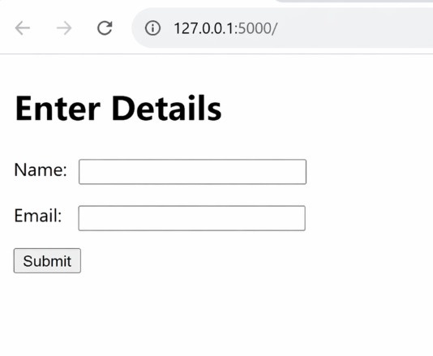

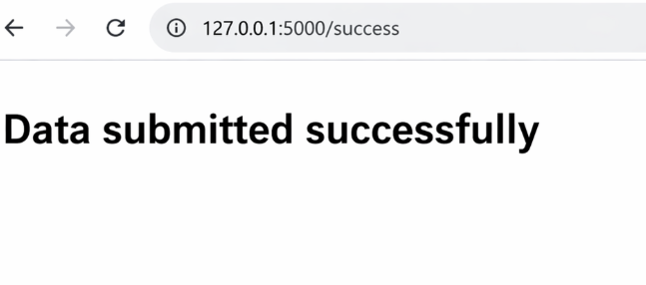

If Error Happens

